**Gebze Teknik Üniversitesi**

**Bilgisayar Mühendisliği**

**s**

**System Programing(CSE 344)**

**Homework #1**

**Berkan AKIN**

**171044073**

**Part #1**

**Problem**

This program should open the specified filename (creating it if necessary) and append num-bytes bytes to the file by using write() to write a byte at a time. By default, the program should open the file with the O_APPEND flag, but if a third command-line argument (x) is supplied, then the O_APPEND flag should be omitted, and instead, the program should perform an lseek(fd, 0, SEEK_END) call before each write(). Run two instances of this program at the same time without the x argument to write 1 million bytes to the same file.

**Solition**

There are two different ways of writing to the file in this program:

1. By default, the file is opened with the O_APPEND flag, and each new write operation appends new data to the end of the file.
2. If a third command-line argument (x) is provided, the O_APPEND flag is omitted, and an lseek(fd, 0, SEEK_END) call is made before each write operation. This way, each write operation goes to the end of the file and adds new data to the end.

The main difference between these two methods is whether the written data is appended to the end of the file or added to a different position in the file. **When the O_APPEND flag is used, the data is always appended to the end of the file, while an lseek() call can add the data to a different position in the file.**

**Program Test Case**

The screenshots below contain the test cases for the first part. The program was run three times, and a difference was observed between the two files in all three runs. The difference is indicated within red.

**Test #1**

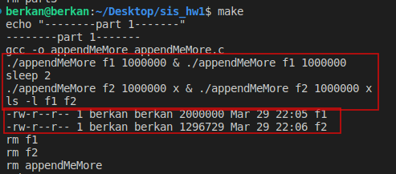

**Test #2**

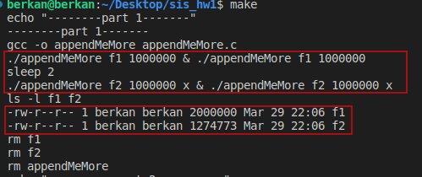

**Test #3**

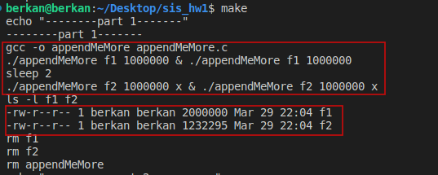

**Results**

After running the program, I observed the difference between writing to files in different ways. First, when I wrote 1 million bytes to the same file without specifying the x argument, each write operation was appended to the end of the file. However, when I repeated the same steps while writing to a different file and specifying the x argument, each write operation was written to a different position in the file instead of being appended to the end.

As a result, the program ran as expected and the difference between writing to files in different ways was clearly seen.

**Part #2**

**Problem**

In this problem, it is required to implement the dup() and dup2() functions using fcntl() and close() where necessary. For the dup2() function, there is a special case where oldfd equals newfd, and in this case, it should be checked whether oldfd is valid. This can be done by checking if fcntl(oldfd, F_GETFL) succeeds. If oldfd is not valid, then the function should return -1 with errno set to EBADF. It can be ignored that dup2() and fcntl() return different errno values for some error cases.

**Solition**

For the dup() function, we can call fcntl() with the F_DUPFD flag to duplicate the file descriptor. This flag returns the lowest file descriptor greater than or equal to the third argument, which is the lowest available file descriptor. If the function succeeds, it returns the duplicated file descriptor, otherwise, it returns -1 with errno set to the appropriate error code.

For the dup2() function, we can check if oldfd is equal to newfd. If so, we check whether oldfd is valid by calling fcntl(oldfd, F_GETFL) and checking whether it succeeds. If it does not succeed, we return -1 with errno set to EBADF. If oldfd is valid and equal to newfd, we simply return newfd. Otherwise, we call close(newfd) to close any open file descriptor with the same value as newfd, and then call fcntl() with the F_DUPFD flag to duplicate oldfd to newfd. If fcntl() succeeds, we return newfd, otherwise, we return -1 with errno set to the appropriate error code.

**Program Test Case**

**Dub1**

The first image shows the implementation of the dup() function. In the second image, the dup() function has been tested. The fd1 file descriptor has been copied to create fd2 using the dup() function. It has been checked whether the created file descriptors point to the same file. A string has been written into a file, and the output of the written text can be seen in the third image.

**İmage 1**

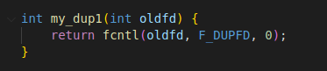

**İmage 2**

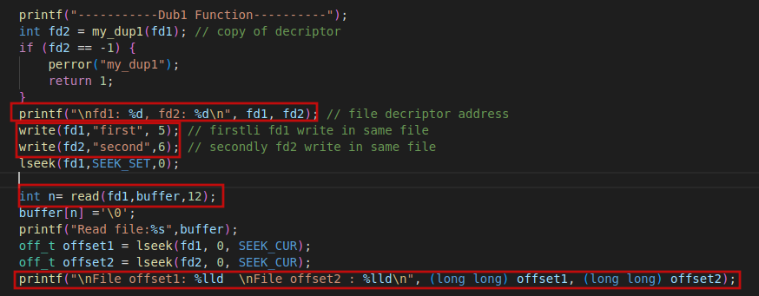

**İmage 3**

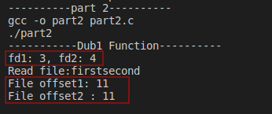

**Dub 2**

The dup2() function has been created. The oldfd file descriptor and newfd file descriptor have been passed as parameters to the function. The validity of the oldfd parameter has been checked, and if it is valid, it is assigned to newfd. The function has been tested for proper operation and explained with screenshots of its execution.

**Image 1**

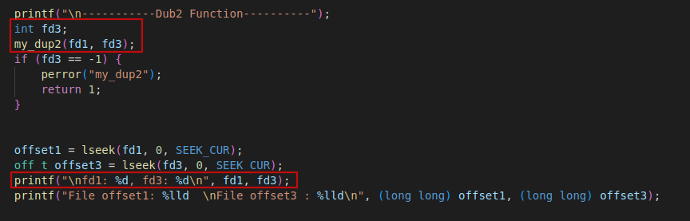

**Image 2**

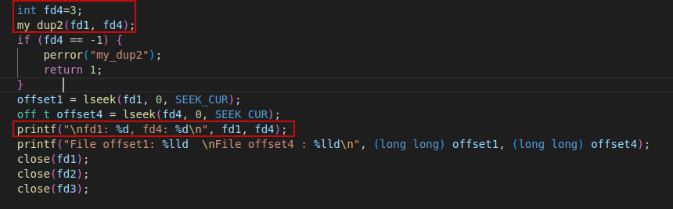

**Image 3**

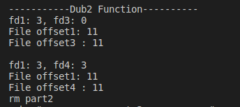

**Part #3**

**Problem**

Write a program to verify that duplicated file descriptors share a fileoffset value and open file

**Solition**

This program will create two file descriptors that point to the same file. Firstly, we will open a file using a file opening function and obtain a file descriptor. Then, using the dup() function, we will create a second file descriptor that contains the same file descriptor as the first one.

Next, we will obtain the offset values that point to the same file for both file descriptors and print them to the screen. Then, by changing an offset value for one file descriptor and printing the offset value again for the other file descriptor, we will confirm that there is a shared offset value between the two file descriptors.

The program will use the fcntl() function to verify the offset values that the files point to and to demonstrate that there is a shared offset value between the two file descriptors.

**Program Test Case**

* In the first test, a file was opened and a duplicate file descriptor was created. The offset values for the created file descriptor were compared and the same value was obtained.

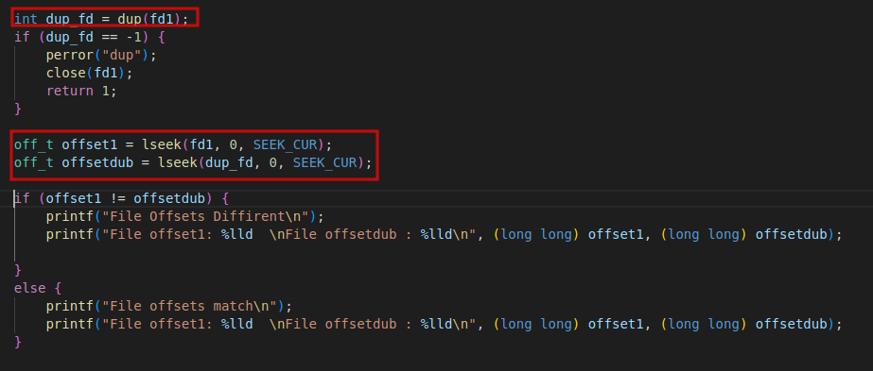

* In the second test, text was written to the file using one file descriptor, and it was observed that both file descriptors progressed in the same way and had the same value.

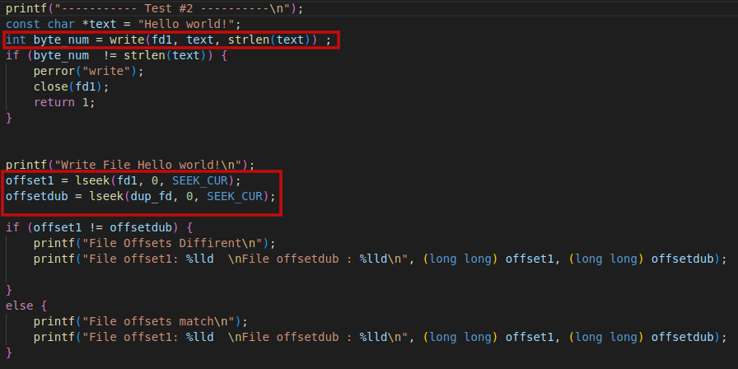

* In the third test, one of the progressed file descriptors was brought back to the starting offset (0 value). The two file descriptors were compared, and it was seen that they had different values.

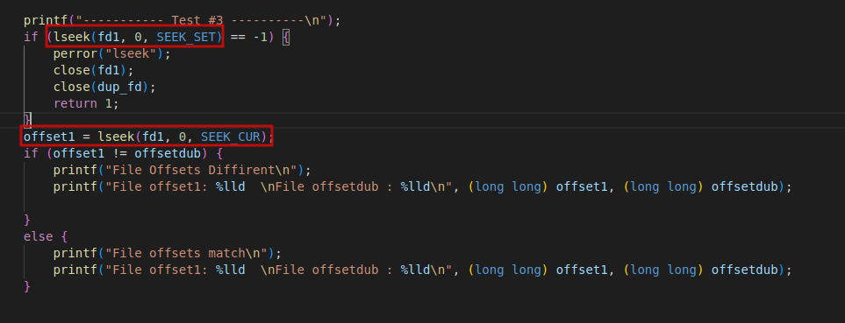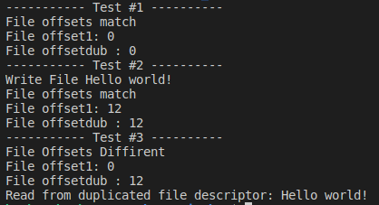

**Results**

When a file descriptor is duplicated, the values of the two file descriptors become the same. When writing to a file using one file descriptor, the values also become the same. When we change the position of one file descriptor, the position of the other one does not change. We observed this in the third test.